The S&P 500 is index consisting of the 500 largest U.S. stocks by market capitalization. It’s often used as a proxy for the overall strength of the economy. Looking at factors that are correlated with the S&P 500 can help individuals and firms predict where the economy is headed. The difficult aspect is deciphering causation vs. correlation because macroeconomic indicators tend to move together, but it’s hard to determine the leading indicators vs. the lagging. This paper is going to look at a few variables that are correlated with the S&P 500, attempt to find predictive indicators, and forecast the expected growth of the S&P 500. The variables that are going to be reviewed are: Treasury rates, Unemployment rates, The Case-Schiller Index, and The Volatility Index (VIX).

**Comparing Treasury Yields and the S&P 500**

The Treasury Yield Curve is often referenced by financial analysts as a signal for how the economy is performing. A normal yield curve is upward sloping because investors require higher yields on treasuries the longer their maturity is due to the uncertainty about the future. A steeper yield curve indicates investors expected economic growth and inflation in the future and a flatter yield curve reflects expectations that the economy will slow. At times the short-term rates exceed long term rates causing the yield curve to invert. This is usually, but not always, a sign of a recession. Comparing the difference in treasury to the S&P 500 can show has these yields can influence the stock market, as seen in Figure 1. (Improve Labels and axis)

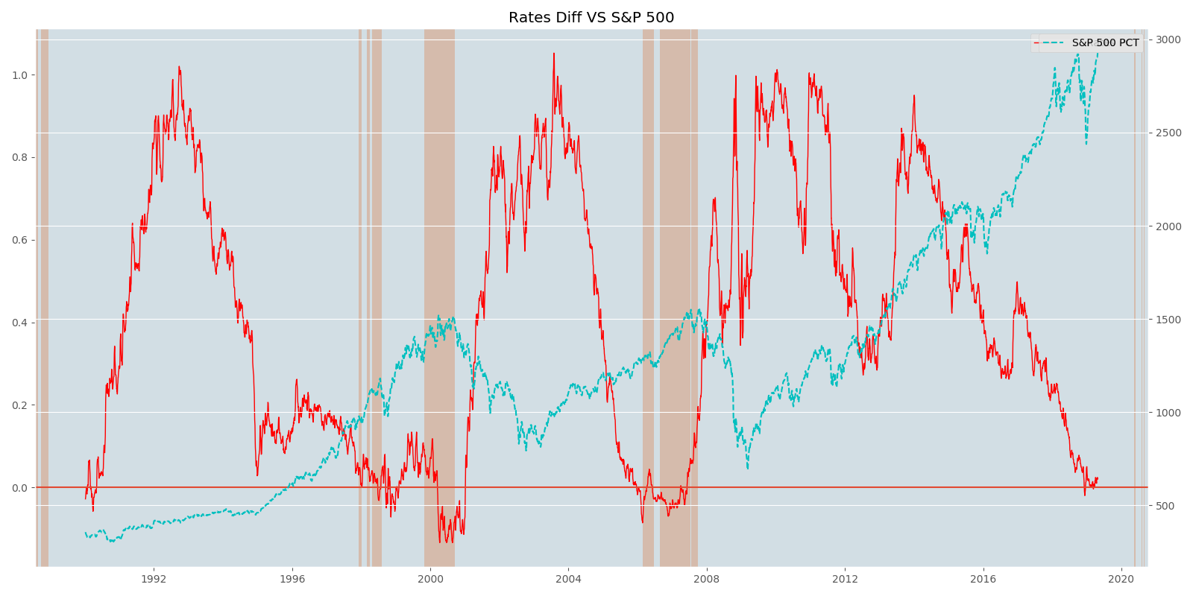

Figure 1

In figure 1, the red line represents the difference between the 5 year and 3 year treasury yields, the shaded sections show the time periods in which it was below zero. The blue line is the adjusted close of the S&P 500. This graph illustrates that the difference in treasury yields and the growth of the S&P 500 are inversely correlated. However, there have been instances where the difference in yields has become negative and a recession hasn’t followed, but the S&P 500 always dips. It’s important to note that to some extent this is a self-fulfilling prophecy; most investors are paying close attention to the treasury yield curve and when they see it invert, they pull money out of stocks and move it to safer assets. The treasury yield curve did briefly invert towards the end of 2018 but has reverted, but looking at how previous inversions occurred it seems likely that it will invert again within a year or two. This could indicate that a recession is looming, but it’s important to look at other economic factors as well.

**The Unemployment Rate and the S&P 500**

One of the primary effects of a recession is a dramatic increase in unemployment. The unemployment has been historically low over the past few years, but its hard to imagine it will stay there for much longer. One may be inclined to believe that the national unemployment rates shouldn’t affect the top 500 U.S. companies that dramatically but this isn’t the case as can be seen in figure 2. When a recession occurs, consumers start to spend less money hurting the profits of all firms regardless of size. As profits decline companies lay off workers leading to even less spending in the economy, causing a downward spiral. An interesting aspect of how unemployment affects firms is that during times of low unemployment, firms have to pay competitive wages to bring in quality workers, in other words the workers have the bargaining power. However, when unemployment rises the bargaining power shifts to the employers, and wages tend to stagnate. This concept is essentially the same as the relationship between inflation and unemployment first described by the economist William Phillips which is now referred to as the Phillips curve. While figure 2 does clearly show there is a relationship between the growth of the S&P 500 and the unemployment rate, the unemployment rate tends to lag behind the S&P 500; this is partly because it’s typically only reported monthly, as a higher frequency would be too volatile and inaccurate to be useful.

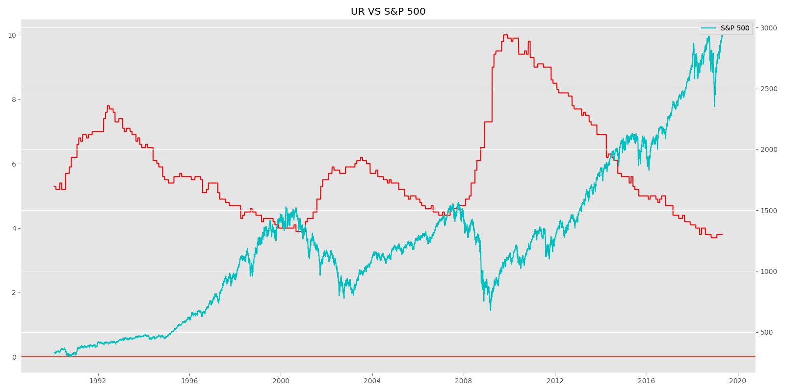

Figure 2

**The Case-Shiller Index and the S&P 500**

The Case-Shiller Index tracks repeat sales of single-family homes over time and is used as a proxy for the housing market. Prior to the bursting of the housing bubble during the 2008 recession, the housing market was often referred to as the bedrock of the American economy. While it may seem odd to look for a correlation between home prices and the S&P 500 it can provide useful information. Figure 3 shows that the Case-Shiller Index plotted and S&P 500 follow the same general trend, but aren’t nearly as correlated as the previous two variables. (They may look more correlated because they are positively correlated where as the previous two were negatively correlated, which makes the correlation not as clear but later there will be regressions that determine the degree of correlation.) There are a few interesting bits of information from this graph. First, it’s clear that the 2008 recession negatively impacted the housing market. What’s even more interesting though is that when the tech bubble burst in 2000, the Case-Shiller index was unaffected. In fact, this was the start of the steepest rise the index had ever seen. Once the 2008 recession ended the index recovered rather quickly and now exceeds the 2007 peak, but does seem to be slowing down.

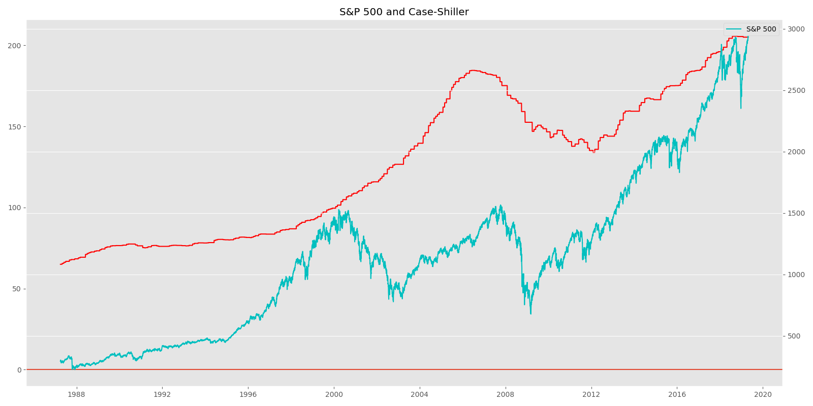

Figure 3

While this information is incredibly valuable when analyzing markets and the U.S. economy as a whole, it doesn’t work as a predictive indicator. This is because housing prices, like unemployment, tend to lag behind the S&P 500. Again, this is partly because of the frequency in which the data is gathered and released. It could also be explained by the way consumers adjust their spending during economic downturns. Mortgages tend to be the last thing people will default on, causing the reduction in home prices to occur significantly after the reduction in other goods.

**The VIX and S&P 500**

Another indicator of economic performance is the volatility index or VIX for short. When markets are strong, they tend to increase at a steady pace and are less volatile. When negative shocks hit the market investors panic and volatility increases significantly. To track volatility people set up the VIX which tracks volatility by…………

Housing prices, like unemployment will most likely lag because this is the last type of debt (mortgages) that people will default on.

* What companies have been added and dropped from the S&P 500 over the last decade or so and what does this mean
* Business cycle
* Adjusting for inflation
* Show each regression or just 1 regression???